UNITED STATES
SECURITIES AND EXCHANGE COMMISSION
Washington, DC 20549

SCHEDULE 14A
(Rule 14a-101)
INFORMATION REQUIRED IN PROXY STATEMENT
SCHEDULE 14A INFORMATION
Proxy Statement Pursuant to Section 14(a) of the
Securities Exchange Act of 1934
(Amendment No. )

Filed by the Registrant ☒
Filed by a Party other than the Registrant ☐
Check the appropriate box:

☐ | Preliminary Proxy Statement

☐ | Confidential, for Use of the Commission Only (as permitted by Rule 14a-6(e)(2))

☐ | Definitive Proxy Statement

☒ | Definitive Additional Materials

☐ | Soliciting Material under §240.14a-12
Zevra Therapeutics, Inc.
(Name of Registrant as Specified in its Charter)
(Name of Person(s) Filing Proxy Statement, if Other Than the Registrant)
Payment of Filing Fee (Check all boxes that apply):

☒ | No fee required

☐ | Fee paid previously with preliminary materials

☐ | Fee computed on table in exhibit required by Item 25(b) per Exchange Act Rules 14a-6(i)(1) and 0-11


NasdaqGS: ZVRA Delivering Significant Value for Zevra Stockholders as a Global Commercialized Rare Disease Leader May 2025

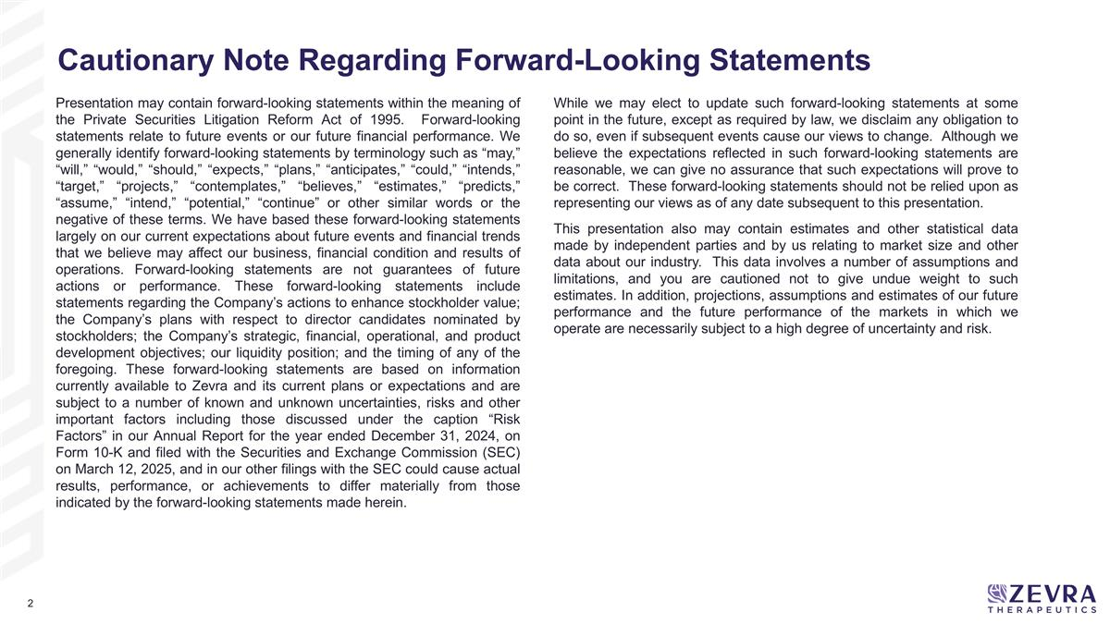
Presentation may contain forward-looking statements within the meaning of the Private Securities Litigation Reform Act of 1995. Forward-looking statements relate to future events or our future financial performance. We generally identify forward-looking statements by terminology such as “may,” “will,” “would,” “should,” “expects,” “plans,” “anticipates,” “could,” “intends,” “target,” “projects,” “contemplates,” “believes,” “estimates,” “predicts,” “assume,” “intend,” “potential,” “continue” or other similar words or the negative of these terms. We have based these forward-looking statements largely on our current expectations about future events and financial trends that we believe may affect our business, financial condition and results of operations. Forward-looking statements are not guarantees of future actions or performance. These forward-looking statements include statements regarding the Company’s actions to enhance stockholder value; the Company’s plans with respect to director candidates nominated by stockholders; the Company’s strategic, financial, operational, and product development objectives; our liquidity position; and the timing of any of the foregoing. These forward-looking statements are based on information currently available to Zevra and its current plans or expectations and are subject to a number of known and unknown uncertainties, risks and other important factors including those discussed under the caption “Risk Factors” in our Annual Report for the year ended December 31, 2024, on Form 10-K and filed with the Securities and Exchange Commission (SEC) on March 12, 2025, and in our other filings with the SEC could cause actual results, performance, or achievements to differ materially from those indicated by the forward-looking statements made herein. While we may elect to update such forward-looking statements at some point in the future, except as required by law, we disclaim any obligation to do so, even if subsequent events cause our views to change. Although we believe the expectations reflected in such forward-looking statements are reasonable, we can give no assurance that such expectations will prove to be correct. These forward-looking statements should not be relied upon as representing our views as of any date subsequent to this presentation. This presentation also may contain estimates and other statistical data made by independent parties and by us relating to market size and other data about our industry. This data involves a number of assumptions and limitations, and you are cautioned not to give undue weight to such estimates. In addition, projections, assumptions and estimates of our future performance and the future performance of the markets in which we operate are necessarily subject to a high degree of uncertainty and risk. Cautionary Note Regarding Forward-Looking Statements

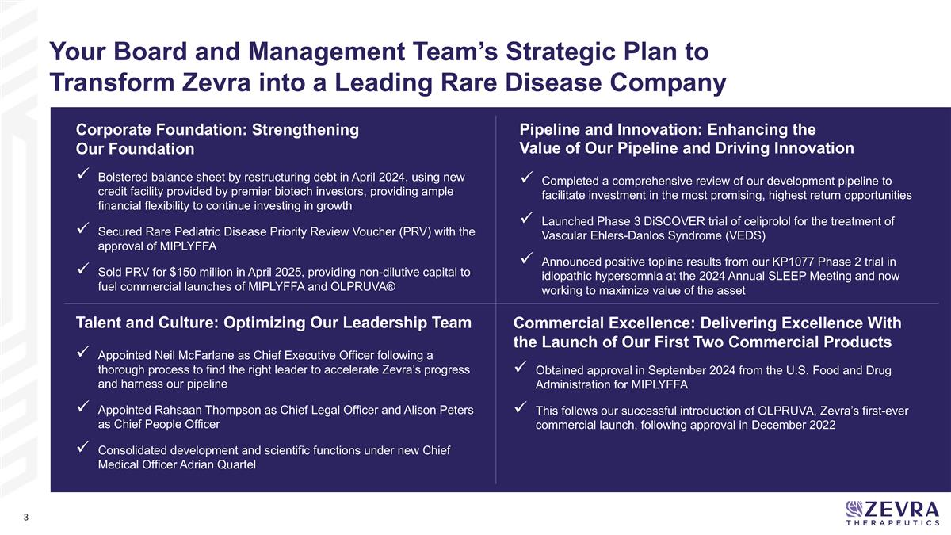
Corporate Foundation: Strengthening Our Foundation Bolstered balance sheet by restructuring debt in April 2024, using new credit facility provided by premier biotech investors, providing ample financial flexibility to continue investing in growth Secured Rare Pediatric Disease Priority Review Voucher (PRV) with the approval of MIPLYFFA Sold PRV for $150 million in April 2025, providing non-dilutive capital to fuel commercial launches of MIPLYFFA and OLPRUVA® Pipeline and Innovation: Enhancing the Value of Our Pipeline and Driving Innovation Completed a comprehensive review of our development pipeline to facilitate investment in the most promising, highest return opportunities Launched Phase 3 DiSCOVER trial of celiprolol for the treatment of Vascular Ehlers-Danlos Syndrome (VEDS) Announced positive topline results from our KP1077 Phase 2 trial in idiopathic hypersomnia at the 2024 Annual SLEEP Meeting and now working to maximize value of the asset Talent and Culture: Optimizing Our Leadership Team Appointed Neil McFarlane as Chief Executive Officer following a thorough process to find the right leader to accelerate Zevra’s progress and harness our pipeline Appointed Rahsaan Thompson as Chief Legal Officer and Alison Peters as Chief People Officer Consolidated development and scientific functions under new Chief Medical Officer Adrian Quartel Commercial Excellence: Delivering Excellence With the Launch of Our First Two Commercial Products Obtained approval in September 2024 from the U.S. Food and Drug Administration for MIPLYFFA This follows our successful introduction of OLPRUVA, Zevra’s first-ever commercial launch, following approval in December 2022 Your Board and Management Team’s Strategic Plan to Transform Zevra into a Leading Rare Disease Company

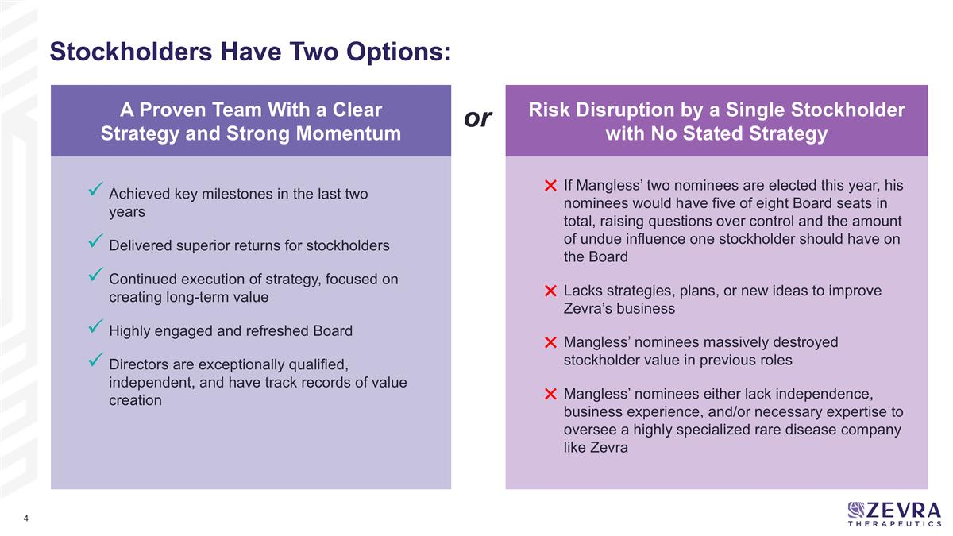
Stockholders Have Two Options: Risk Disruption by a Single Stockholder with No Stated Strategy or A Proven Team With a Clear Strategy and Strong Momentum If Mangless’ two nominees are elected this year, his nominees would have five of eight Board seats in total, raising questions over control and the amount of undue influence one stockholder should have on the Board Lacks strategies, plans, or new ideas to improve Zevra’s business Mangless’ nominees massively destroyed stockholder value in previous roles Mangless’ nominees either lack independence, business experience, and/or necessary expertise to oversee a highly specialized rare disease company like Zevra Achieved key milestones in the last two years Delivered superior returns for stockholders Continued execution of strategy, focused on creating long-term value Highly engaged and refreshed Board Directors are exceptionally qualified, independent, and have track records of value creation

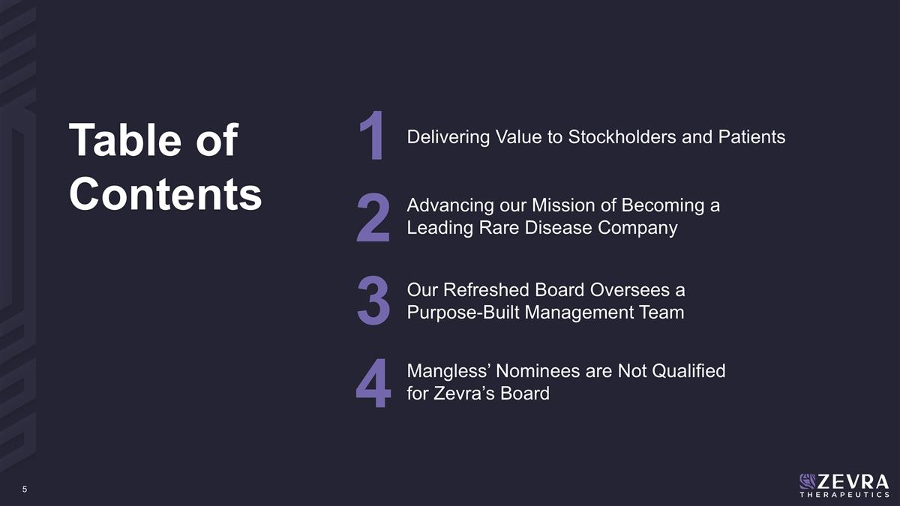
Delivering Value to Stockholders and Patients Advancing our Mission of Becoming a Leading Rare Disease Company 1 2 Our Refreshed Board Oversees a Purpose-Built Management Team 3 Mangless’ Nominees are Not Qualified for Zevra’s Board 4 Table of Contents


Delivering Value to Stockholders and Patients 1

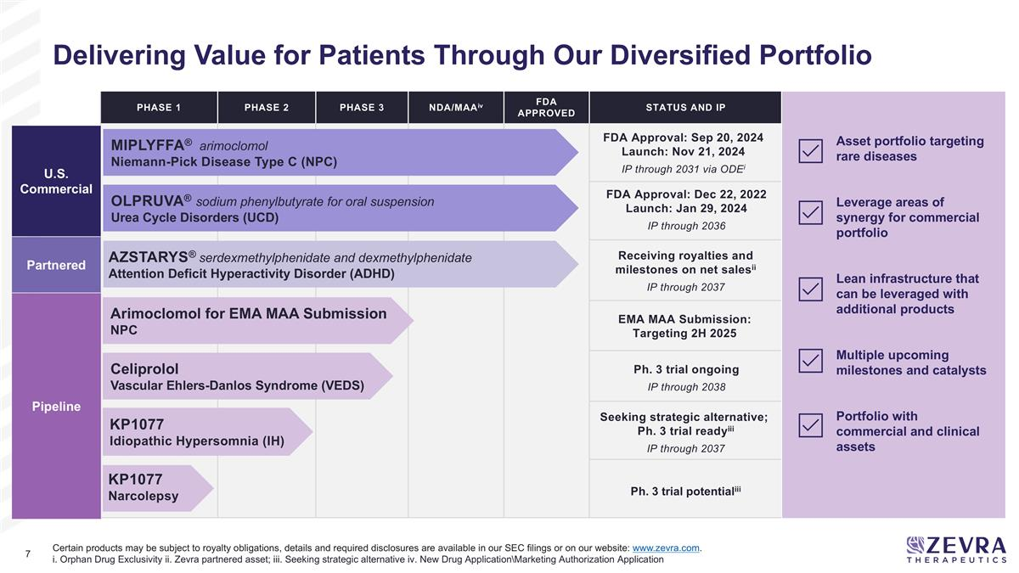
PHASE 1 PHASE 2 PHASE 3 NDA/MAAiv FDA Approved Status and IP KP1077 Idiopathic Hypersomnia (IH) KP1077 Narcolepsy AZSTARYS® serdexmethylphenidate and dexmethylphenidate Attention Deficit Hyperactivity Disorder (ADHD) Celiprolol Vascular Ehlers-Danlos Syndrome (VEDS) Certain products may be subject to royalty obligations, details and required disclosures are available in our SEC filings or on our website: www.zevra.com. i. Orphan Drug Exclusivity ii. Zevra partnered asset; iii. Seeking strategic alternative iv. New Drug Application\Marketing Authorization Application Asset portfolio targeting rare diseases Leverage areas of synergy for commercial portfolio Lean infrastructure that can be leveraged with additional products Multiple upcoming milestones and catalysts Portfolio with commercial and clinical assets U.S. Commercial Partnered Pipeline FDA Approval: Sep 20, 2024 Launch: Nov 21, 2024 IP through 2031 via ODEi FDA Approval: Dec 22, 2022 Launch: Jan 29, 2024 IP through 2036 Receiving royalties and milestones on net salesii IP through 2037 Seeking strategic alternative; Ph. 3 trial readyiii IP through 2037 Ph. 3 trial potentialiii Ph. 3 trial ongoing IP through 2038 Arimoclomol for EMA MAA Submission NPC EMA MAA Submission: Targeting 2H 2025 OLPRUVA® sodium phenylbutyrate for oral suspension Urea Cycle Disorders (UCD) MIPLYFFA® arimoclomol Niemann-Pick Disease Type C (NPC) Delivering Value for Patients Through Our Diversified Portfolio

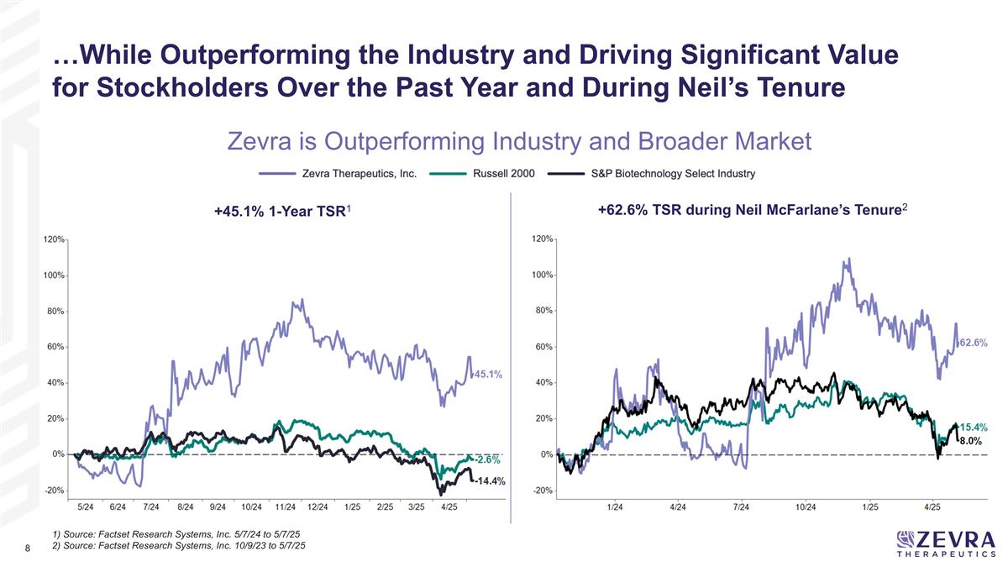
+62.6% TSR during Neil McFarlane’s Tenure2 +45.1% 1-Year TSR1 Zevra is Outperforming Industry and Broader Market …While Outperforming the Industry and Driving Significant Value for Stockholders Over the Past Year and During Neil’s Tenure 1) Source: Factset Research Systems, Inc. 5/7/24 to 5/7/25 2) Source: Factset Research Systems, Inc. 10/9/23 to 5/7/25

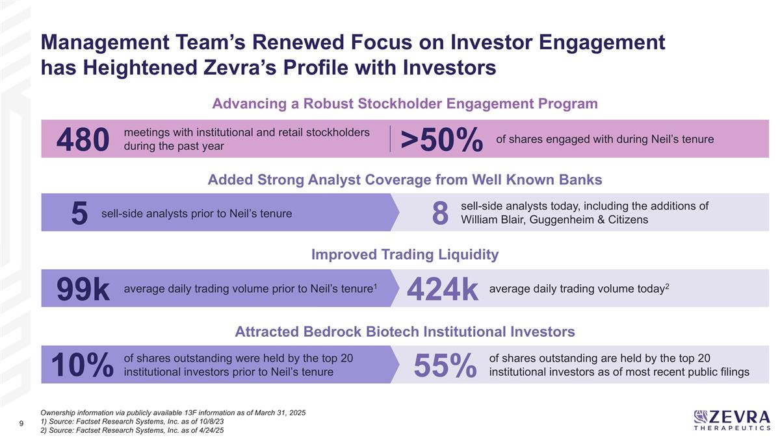
Ownership information via publicly available 13F information as of March 31, 2025 1) Source: Factset Research Systems, Inc. as of 10/8/23 2) Source: Factset Research Systems, Inc. as of 4/24/25 Management Team’s Renewed Focus on Investor Engagement has Heightened Zevra’s Profile with Investors meetings with institutional and retail stockholders during the past year of shares engaged with during Neil’s tenure >50% Advancing a Robust Stockholder Engagement Program sell-side analysts prior to Neil’s tenure sell-side analysts today, including the additions of William Blair, Guggenheim & Citizens 8 5 Added Strong Analyst Coverage from Well Known Banks average daily trading volume prior to Neil’s tenure1 average daily trading volume today2 424k 99k Improved Trading Liquidity of shares outstanding were held by the top 20 institutional investors prior to Neil’s tenure 55% 10% Attracted Bedrock Biotech Institutional Investors 480 of shares outstanding are held by the top 20 institutional investors as of most recent public filings

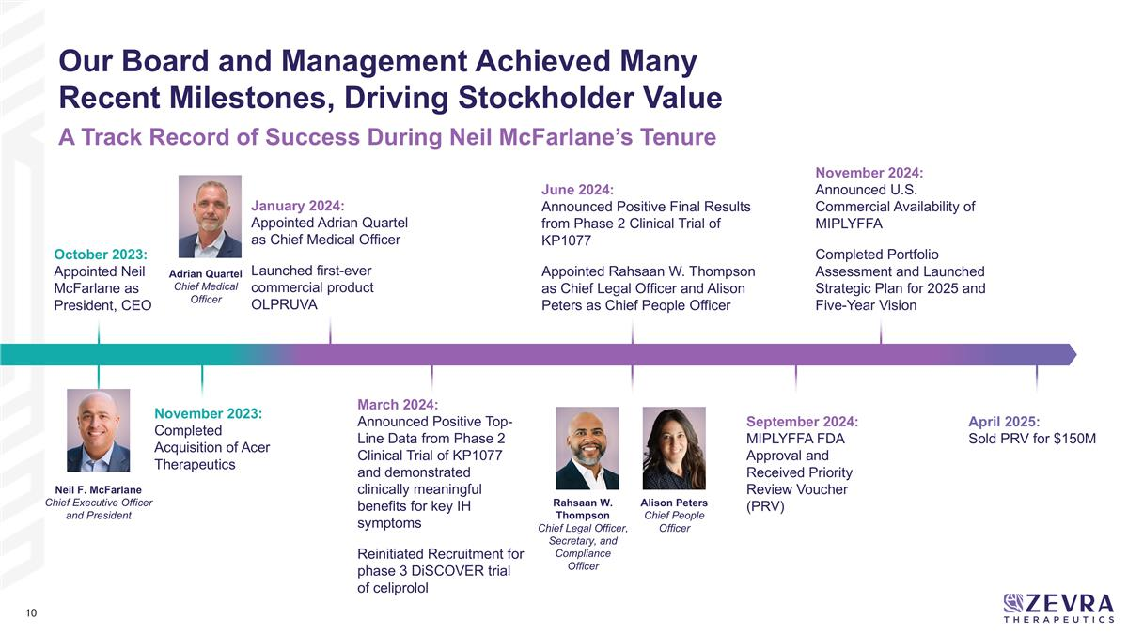
October 2023: Appointed Neil McFarlane as President, CEO November 2023: Completed Acquisition of Acer Therapeutics June 2024: Announced Positive Final Results from Phase 2 Clinical Trial of KP1077 Appointed Rahsaan W. Thompson as Chief Legal Officer and Alison Peters as Chief People Officer September 2024: MIPLYFFA FDA Approval and Received Priority Review Voucher (PRV) November 2024: Announced U.S. Commercial Availability of MIPLYFFA Completed Portfolio Assessment and Launched Strategic Plan for 2025 and Five-Year Vision April 2025: Sold PRV for $150M January 2024: Appointed Adrian Quartel as Chief Medical Officer Launched first-ever commercial product OLPRUVA March 2024: Announced Positive Top-Line Data from Phase 2 Clinical Trial of KP1077 and demonstrated clinically meaningful benefits for key IH symptoms Reinitiated Recruitment for phase 3 DiSCOVER trial of celiprolol Neil F. McFarlane Chief Executive Officer and President Rahsaan W. Thompson Chief Legal Officer, Secretary, and Compliance Officer Alison Peters Chief People Officer Our Board and Management Achieved Many Recent Milestones, Driving Stockholder Value A Track Record of Success During Neil McFarlane’s Tenure Adrian Quartel Chief Medical Officer

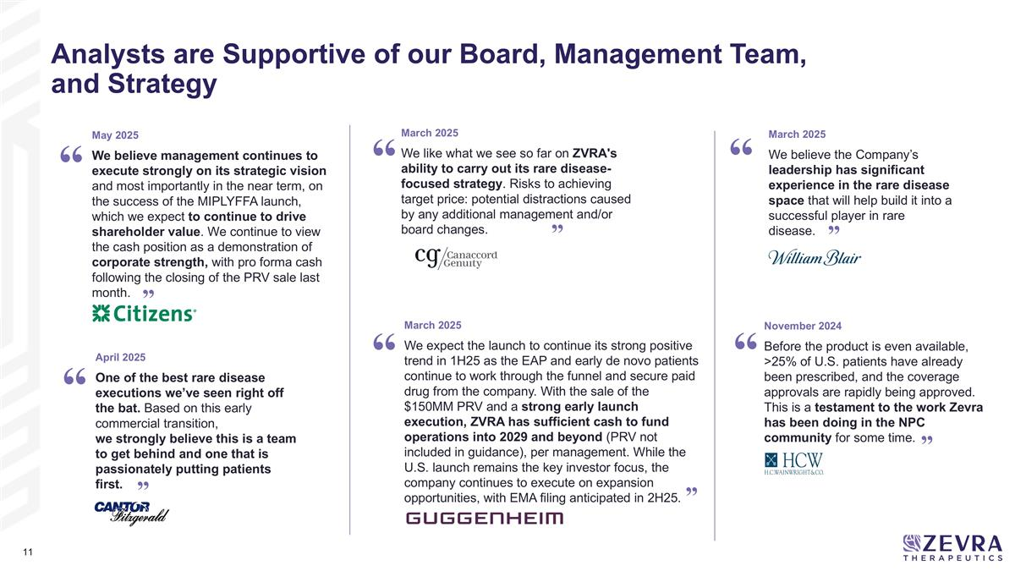
Analysts are Supportive of our Board, Management Team, and Strategy April 2025 One of the best rare disease executions we’ve seen right off the bat. Based on this early commercial transition, we strongly believe this is a team to get behind and one that is passionately putting patients first. March 2025 We believe the Company’s leadership has significant experience in the rare disease space that will help build it into a successful player in rare disease. “ ” “ ” March 2025 We like what we see so far on ZVRA's ability to carry out its rare disease-focused strategy. Risks to achieving target price: potential distractions caused by any additional management and/or board changes. “ ” November 2024 Before the product is even available, >25% of U.S. patients have already been prescribed, and the coverage approvals are rapidly being approved. This is a testament to the work Zevra has been doing in the NPC community for some time. “ ” “ March 2025 We expect the launch to continue its strong positive trend in 1H25 as the EAP and early de novo patients continue to work through the funnel and secure paid drug from the company. With the sale of the $150MM PRV and a strong early launch execution, ZVRA has sufficient cash to fund operations into 2029 and beyond (PRV not included in guidance), per management. While the U.S. launch remains the key investor focus, the company continues to execute on expansion opportunities, with EMA filing anticipated in 2H25. ” May 2025 We believe management continues to execute strongly on its strategic vision and most importantly in the near term, on the success of the MIPLYFFA launch, which we expect to continue to drive shareholder value. We continue to view the cash position as a demonstration of corporate strength, with pro forma cash following the closing of the PRV sale last month. ” “


2 Advancing our Mission of Becoming a Leading Rare Disease Company

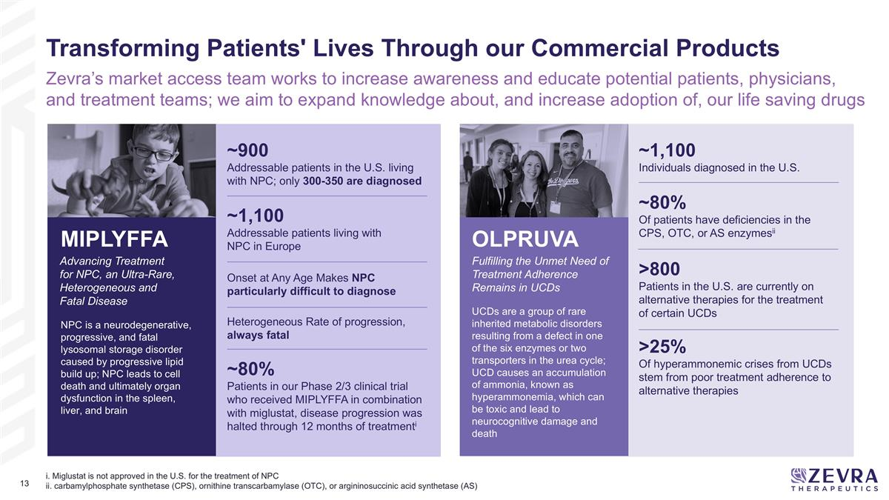
Onset at Any Age Makes NPC particularly difficult to diagnose Heterogeneous Rate of progression, always fatal i. Miglustat is not approved in the U.S. for the treatment of NPC ii. carbamylphosphate synthetase (CPS), ornithine transcarbamylase (OTC), or argininosuccinic acid synthetase (AS) Transforming Patients' Lives Through our Commercial Products Zevra’s market access team works to increase awareness and educate potential patients, physicians, and treatment teams; we aim to expand knowledge about, and increase adoption of, our life saving drugs Advancing Treatment for NPC, an Ultra-Rare, Heterogeneous and Fatal Disease MIPLYFFA ~900 Addressable patients in the U.S. living with NPC; only 300-350 are diagnosed ~1,100 Addressable patients living with NPC in Europe NPC is a neurodegenerative, progressive, and fatal lysosomal storage disorder caused by progressive lipid build up; NPC leads to cell death and ultimately organ dysfunction in the spleen, liver, and brain ~80% Patients in our Phase 2/3 clinical trial who received MIPLYFFA in combination with miglustat, disease progression was halted through 12 months of treatmenti Fulfilling the Unmet Need of Treatment Adherence Remains in UCDs OLPRUVA UCDs are a group of rare inherited metabolic disorders resulting from a defect in one of the six enzymes or two transporters in the urea cycle; UCD causes an accumulation of ammonia, known as hyperammonemia, which can be toxic and lead to neurocognitive damage and death ~1,100 Individuals diagnosed in the U.S. ~80% Of patients have deficiencies in the CPS, OTC, or AS enzymesii >800 Patients in the U.S. are currently on alternative therapies for the treatment of certain UCDs >25% Of hyperammonemic crises from UCDs stem from poor treatment adherence to alternative therapies

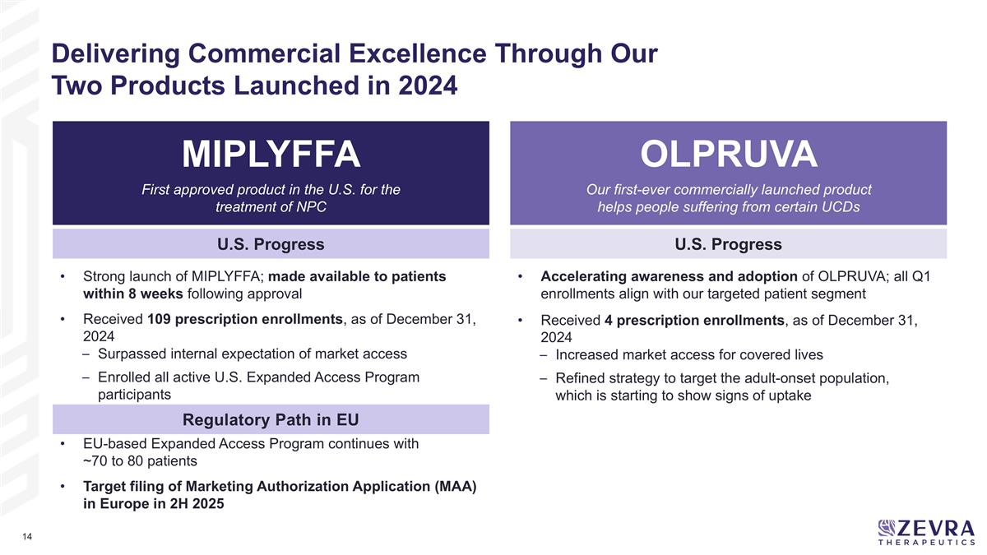
Our first-ever commercially launched product helps people suffering from certain UCDs MIPLYFFA OLPRUVA U.S. Progress U.S. Progress Regulatory Path in EU EU-based Expanded Access Program continues with ~70 to 80 patients Target filing of Marketing Authorization Application (MAA) in Europe in 2H 2025 Strong launch of MIPLYFFA; made available to patients within 8 weeks following approval Received 109 prescription enrollments, as of December 31, 2024 Surpassed internal expectation of market access Enrolled all active U.S. Expanded Access Program participants Accelerating awareness and adoption of OLPRUVA; all Q1 enrollments align with our targeted patient segment Received 4 prescription enrollments, as of December 31, 2024 Increased market access for covered lives Refined strategy to target the adult-onset population, which is starting to show signs of uptake First approved product in the U.S. for the treatment of NPC Delivering Commercial Excellence Through Our Two Products Launched in 2024

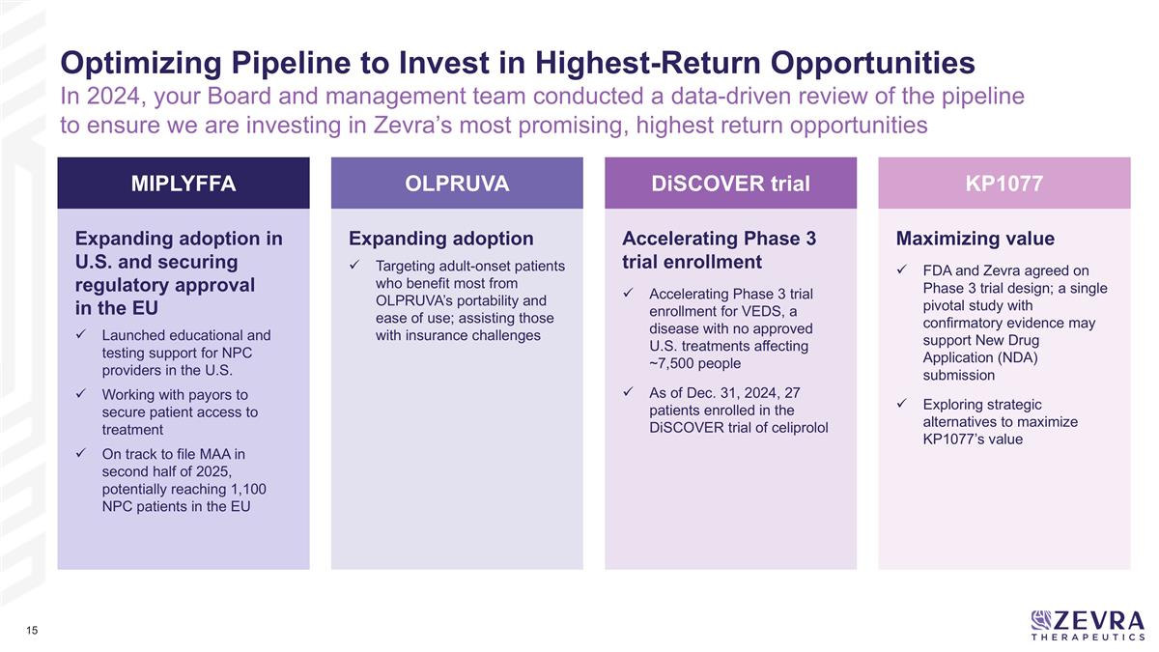
MIPLYFFA Expanding adoption in U.S. and securing regulatory approval in the EU Launched educational and testing support for NPC providers in the U.S. Working with payors to secure patient access to treatment On track to file MAA in second half of 2025, potentially reaching 1,100 NPC patients in the EU OLPRUVA Expanding adoption Targeting adult-onset patients who benefit most from OLPRUVA’s portability and ease of use; assisting those with insurance challenges DiSCOVER trial Accelerating Phase 3 trial enrollment Accelerating Phase 3 trial enrollment for VEDS, a disease with no approved U.S. treatments affecting ~7,500 people As of Dec. 31, 2024, 27 patients enrolled in the DiSCOVER trial of celiprolol Optimizing Pipeline to Invest in Highest-Return Opportunities In 2024, your Board and management team conducted a data-driven review of the pipeline to ensure we are investing in Zevra’s most promising, highest return opportunities KP1077 Maximizing value FDA and Zevra agreed on Phase 3 trial design; a single pivotal study with confirmatory evidence may support New Drug Application (NDA) submission Exploring strategic alternatives to maximize KP1077’s value


3 Our Refreshed Board Oversees a Purpose-Built Management Team

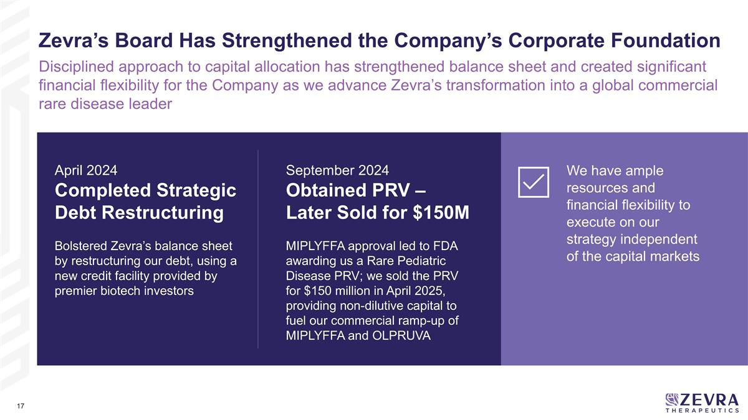
April 2024 Completed Strategic Debt Restructuring Bolstered Zevra’s balance sheet by restructuring our debt, using a new credit facility provided by premier biotech investors Zevra’s Board Has Strengthened the Company’s Corporate Foundation Disciplined approach to capital allocation has strengthened balance sheet and created significant financial flexibility for the Company as we advance Zevra’s transformation into a global commercial rare disease leader September 2024 Obtained PRV – Later Sold for $150M MIPLYFFA approval led to FDA awarding us a Rare Pediatric Disease PRV; we sold the PRV for $150 million in April 2025, providing non-dilutive capital to fuel our commercial ramp-up of MIPLYFFA and OLPRUVA We have ample resources and financial flexibility to execute on our strategy independent of the capital markets

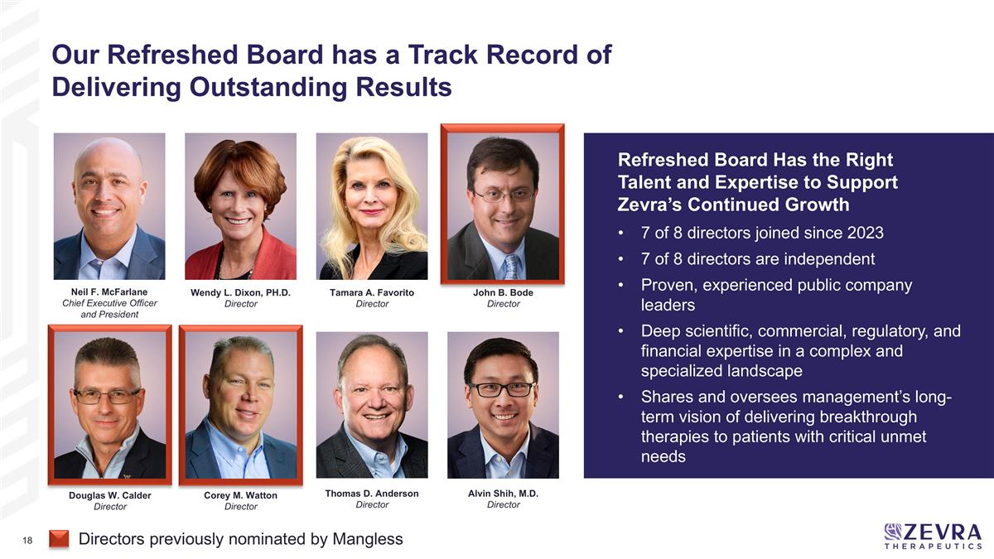
Neil F. McFarlane Chief Executive Officer and President Alvin Shih, M.D. Director Thomas D. Anderson Director Douglas W. Calder Director Tamara A. Favorito Director Wendy L. Dixon, PH.D. Director Corey M. Watton Director John B. Bode Director 7 of 8 directors joined since 2023 7 of 8 directors are independent Proven, experienced public company leaders Deep scientific, commercial, regulatory, and financial expertise in a complex and specialized landscape Shares and oversees management’s long-term vision of delivering breakthrough therapies to patients with critical unmet needs Refreshed Board Has the Right Talent and Expertise to Support Zevra’s Continued Growth Our Refreshed Board has a Track Record of Delivering Outstanding Results Directors previously nominated by Mangless

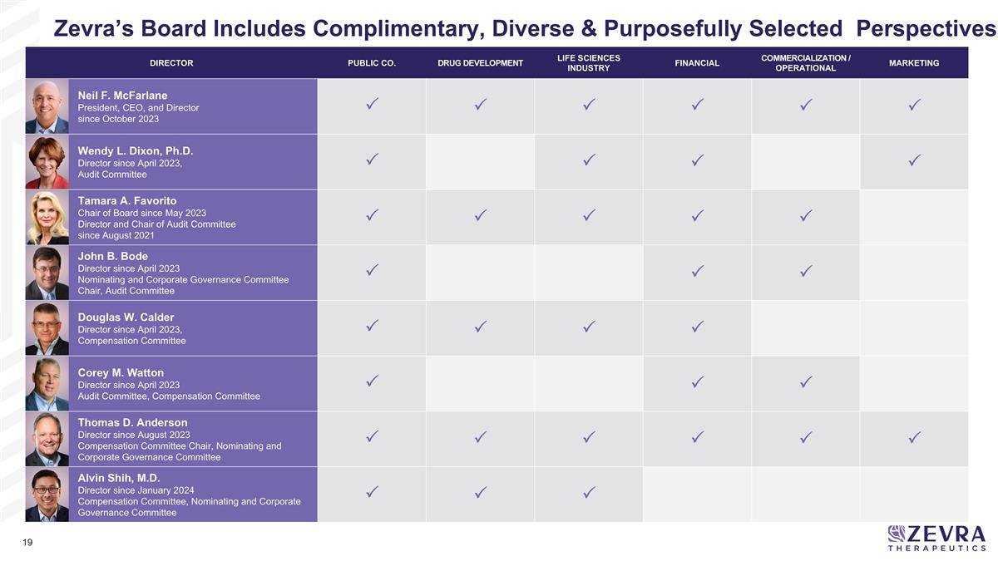
DIRECTOR PUBLIC CO. DRUG DEVELOPMENT LIFE SCIENCES INDUSTRY FINANCIAL COMMERCIALIZATION / OPERATIONAL MARKETING Neil F. McFarlane President, CEO, and Director since October 2023 P P P P P P Wendy L. Dixon, Ph.D. Director since April 2023, Audit Committee P P P P Tamara A. Favorito Chair of Board since May 2023 Director and Chair of Audit Committee since August 2021 P P P P P John B. Bode Director since April 2023 Nominating and Corporate Governance Committee Chair, Audit Committee P P P Douglas W. Calder Director since April 2023, Compensation Committee P P P P Corey M. Watton Director since April 2023 Audit Committee, Compensation Committee P P P Thomas D. Anderson Director since August 2023 Compensation Committee Chair, Nominating and Corporate Governance Committee P P P P P P Alvin Shih, M.D. Director since January 2024 Compensation Committee, Nominating and Corporate Governance Committee P P P Zevra’s Board Includes Complimentary, Diverse & Purposefully Selected Perspectives

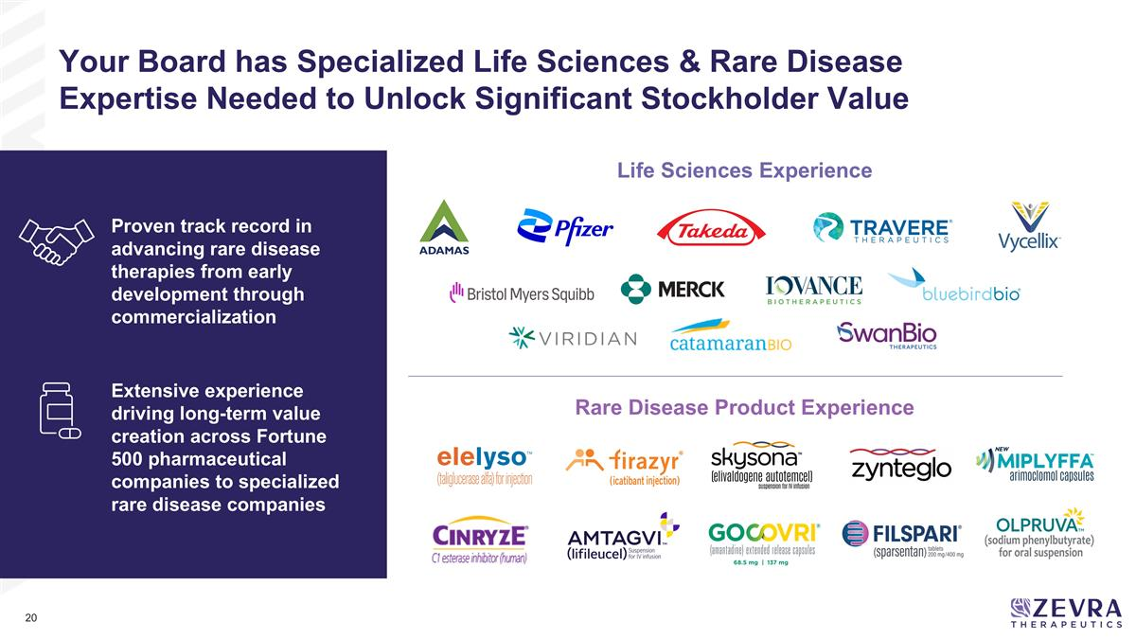
Life Sciences Experience Rare Disease Product Experience Proven track record in advancing rare disease therapies from early development through commercialization Extensive experience driving long-term value creation across Fortune 500 pharmaceutical companies to specialized rare disease companies Your Board has Specialized Life Sciences & Rare Disease Expertise Needed to Unlock Significant Stockholder Value

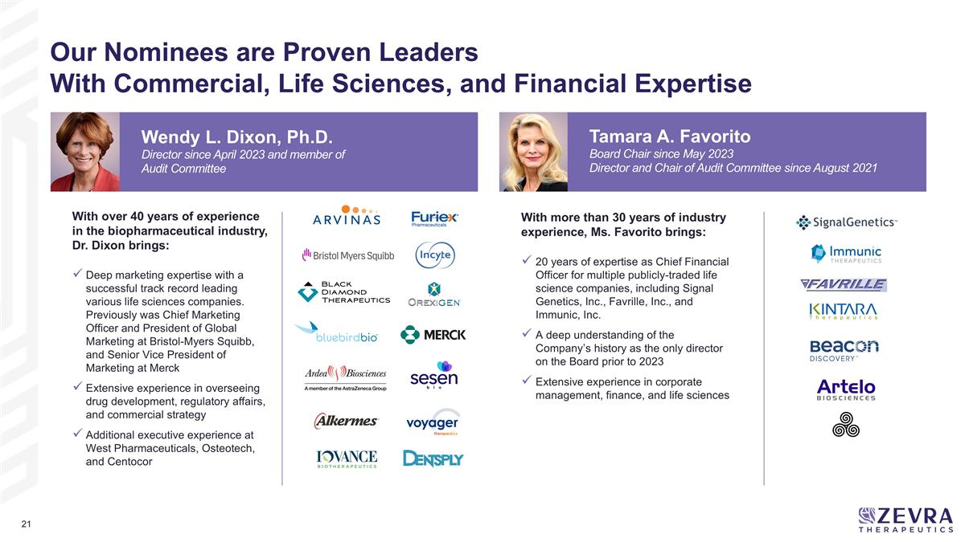
With more than 30 years of industry experience, Ms. Favorito brings: 20 years of expertise as Chief Financial Officer for multiple publicly-traded life science companies, including Signal Genetics, Inc., Favrille, Inc., and Immunic, Inc. A deep understanding of the Company’s history as the only director on the Board prior to 2023 Extensive experience in corporate management, finance, and life sciences Tamara A. Favorito Board Chair since May 2023 Director and Chair of Audit Committee since August 2021 Our Nominees are Proven Leaders With Commercial, Life Sciences, and Financial Expertise With over 40 years of experience in the biopharmaceutical industry, Dr. Dixon brings: Deep marketing expertise with a successful track record leading various life sciences companies. Previously was Chief Marketing Officer and President of Global Marketing at Bristol-Myers Squibb, and Senior Vice President of Marketing at Merck Extensive experience in overseeing drug development, regulatory affairs, and commercial strategy Additional executive experience at West Pharmaceuticals, Osteotech, and Centocor Wendy L. Dixon, Ph.D. Director since April 2023 and member of Audit Committee


4 Mangless’ Nominees are Not Qualified for Zevra’s Board

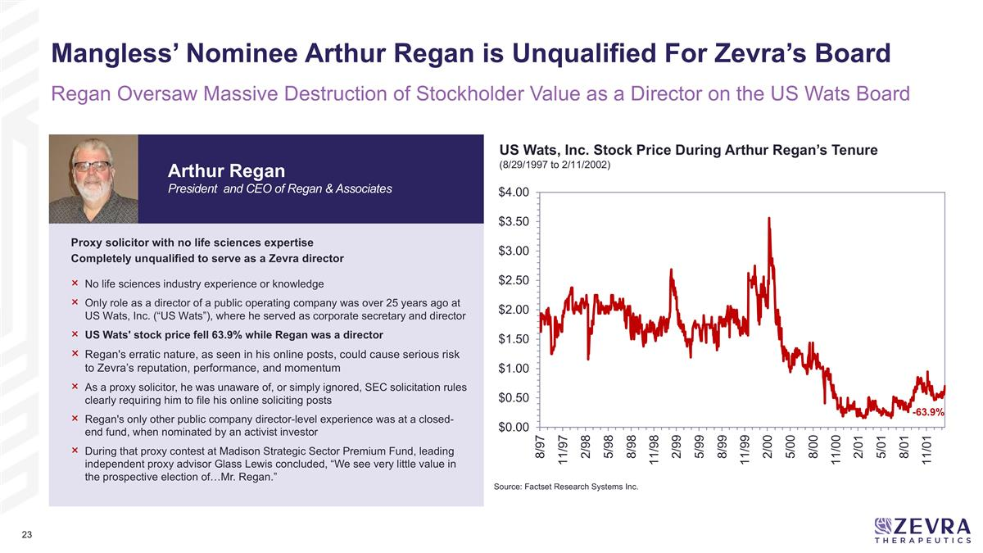
Proxy solicitor with no life sciences expertise Completely unqualified to serve as a Zevra director No life sciences industry experience or knowledge Only role as a director of a public operating company was over 25 years ago at US Wats, Inc. (“US Wats”), where he served as corporate secretary and director US Wats' stock price fell 63.9% while Regan was a director Regan's erratic nature, as seen in his online posts, could cause serious risk to Zevra’s reputation, performance, and momentum As a proxy solicitor, he was unaware of, or simply ignored, SEC solicitation rules clearly requiring him to file his online soliciting posts Regan's only other public company director-level experience was at a closed-end fund, when nominated by an activist investor During that proxy contest at Madison Strategic Sector Premium Fund, leading independent proxy advisor Glass Lewis concluded, “We see very little value in the prospective election of…Mr. Regan.” Source: Factset Research Systems Inc. Arthur Regan President and CEO of Regan & Associates -63.9% Mangless’ Nominee Arthur Regan is Unqualified For Zevra’s Board Regan Oversaw Massive Destruction of Stockholder Value as a Director on the US Wats Board US Wats, Inc. Stock Price During Arthur Regan’s Tenure (8/29/1997 to 2/11/2002)

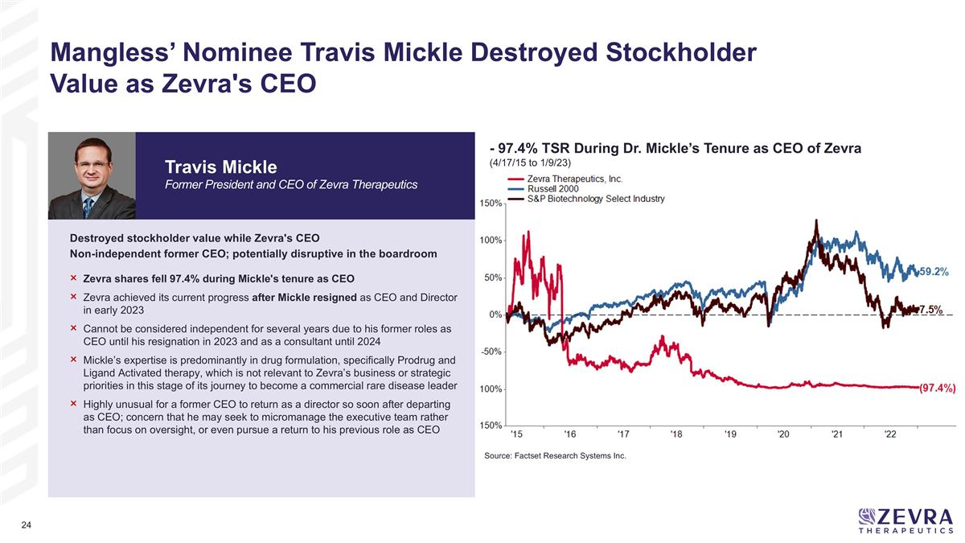
Destroyed stockholder value while Zevra's CEO Non-independent former CEO; potentially disruptive in the boardroom Zevra shares fell 97.4% during Mickle's tenure as CEO Zevra achieved its current progress after Mickle resigned as CEO and Director in early 2023 Cannot be considered independent for several years due to his former roles as CEO until his resignation in 2023 and as a consultant until 2024 Mickle’s expertise is predominantly in drug formulation, specifically Prodrug and Ligand Activated therapy, which is not relevant to Zevra’s business or strategic priorities in this stage of its journey to become a commercial rare disease leader Highly unusual for a former CEO to return as a director so soon after departing as CEO; concern that he may seek to micromanage the executive team rather than focus on oversight, or even pursue a return to his previous role as CEO Mangless’ Nominee Travis Mickle Destroyed Stockholder Value as Zevra's CEO Travis Mickle Former President and CEO of Zevra Therapeutics Source: Factset Research Systems Inc. - 97.4% TSR During Dr. Mickle’s Tenure as CEO of Zevra (4/17/15 to 1/9/23)

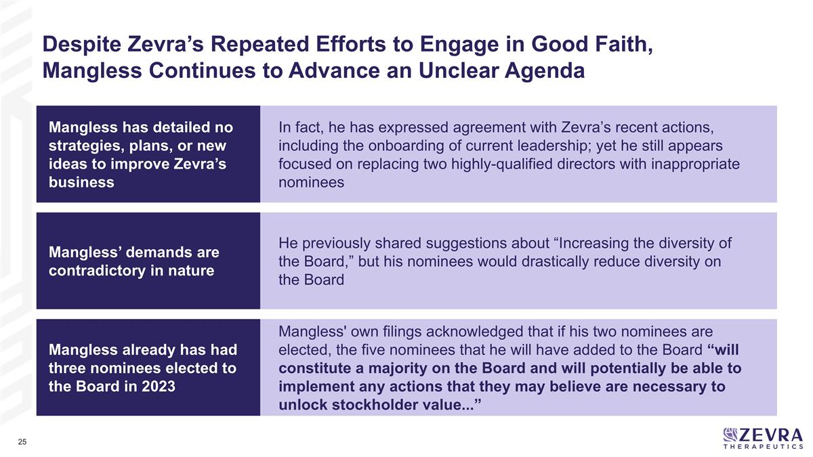
Despite Zevra’s Repeated Efforts to Engage in Good Faith, Mangless Continues to Advance an Unclear Agenda Mangless already has had three nominees elected to the Board in 2023 Mangless' own filings acknowledged that if his two nominees are elected, the five nominees that he will have added to the Board “will constitute a majority on the Board and will potentially be able to implement any actions that they may believe are necessary to unlock stockholder value...” Mangless has detailed no strategies, plans, or new ideas to improve Zevra’s business Mangless’ demands are contradictory in nature In fact, he has expressed agreement with Zevra’s recent actions, including the onboarding of current leadership; yet he still appears focused on replacing two highly-qualified directors with inappropriate nominees He previously shared suggestions about “Increasing the diversity of the Board,” but his nominees would drastically reduce diversity on the Board

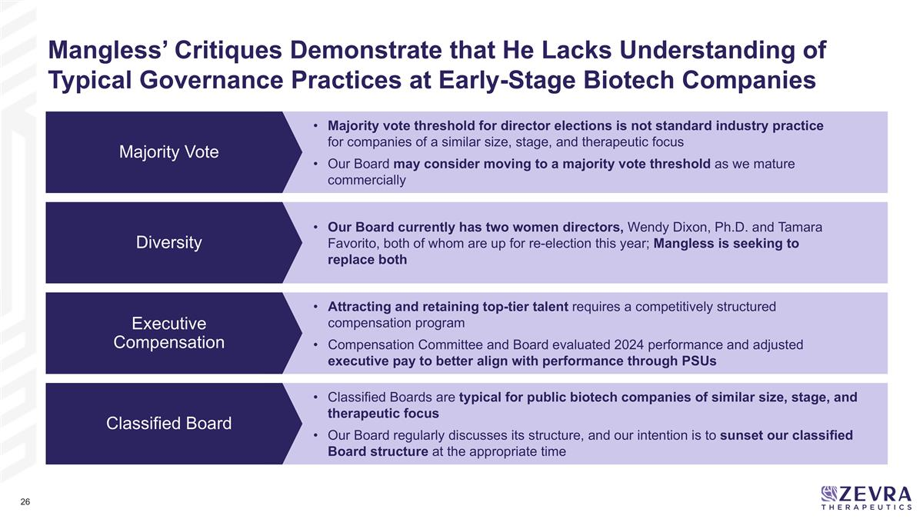
Mangless’ Critiques Demonstrate that He Lacks Understanding of Typical Governance Practices at Early-Stage Biotech Companies Majority vote threshold for director elections is not standard industry practice for companies of a similar size, stage, and therapeutic focus Our Board may consider moving to a majority vote threshold as we mature commercially Classified Boards are typical for public biotech companies of similar size, stage, and therapeutic focus Our Board regularly discusses its structure, and our intention is to sunset our classified Board structure at the appropriate time Our Board currently has two women directors, Wendy Dixon, Ph.D. and Tamara Favorito, both of whom are up for re-election this year; Mangless is seeking to replace both Attracting and retaining top-tier talent requires a competitively structured compensation program Compensation Committee and Board evaluated 2024 performance and adjusted executive pay to better align with performance through PSUs Diversity Executive Compensation Classified Board Majority Vote


Vote for the Nominees with the Experience and Expertise to Lead Zevra

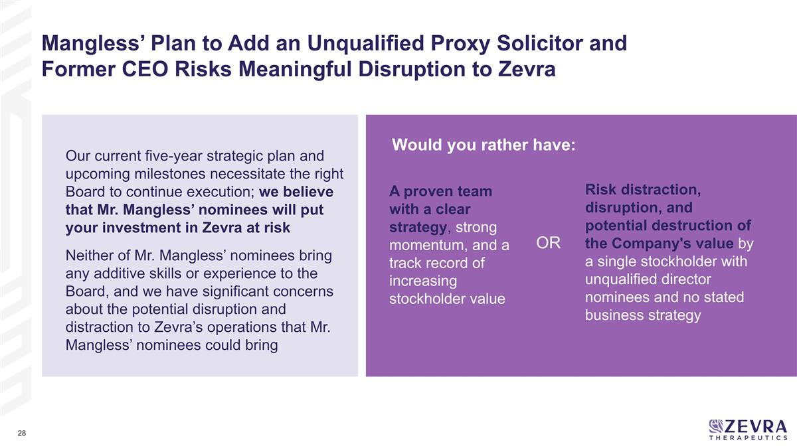
Would you rather have: Mangless’ Plan to Add an Unqualified Proxy Solicitor and Former CEO Risks Meaningful Disruption to Zevra Our current five-year strategic plan and upcoming milestones necessitate the right Board to continue execution; we believe that Mr. Mangless’ nominees will put your investment in Zevra at risk Neither of Mr. Mangless’ nominees bring any additive skills or experience to the Board, and we have significant concerns about the potential disruption and distraction to Zevra’s operations that Mr. Mangless’ nominees could bring Risk distraction, disruption, and potential destruction of the Company's value by a single stockholder with unqualified director nominees and no stated business strategy A proven team with a clear strategy, strong momentum, and a track record of increasing stockholder value OR

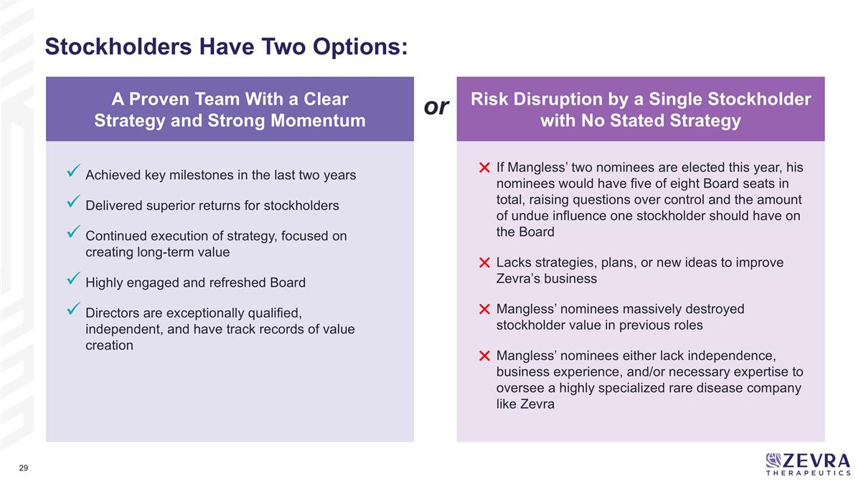
Stockholders Have Two Options: Risk Disruption by a Single Stockholder with No Stated Strategy or A Proven Team With a Clear Strategy and Strong Momentum If Mangless’ two nominees are elected this year, his nominees would have five of eight Board seats in total, raising questions over control and the amount of undue influence one stockholder should have on the Board Lacks strategies, plans, or new ideas to improve Zevra’s business Mangless’ nominees massively destroyed stockholder value in previous roles Mangless’ nominees either lack independence, business experience, and/or necessary expertise to oversee a highly specialized rare disease company like Zevra Achieved key milestones in the last two years Delivered superior returns for stockholders Continued execution of strategy, focused on creating long-term value Highly engaged and refreshed Board Directors are exceptionally qualified, independent, and have track records of value creation

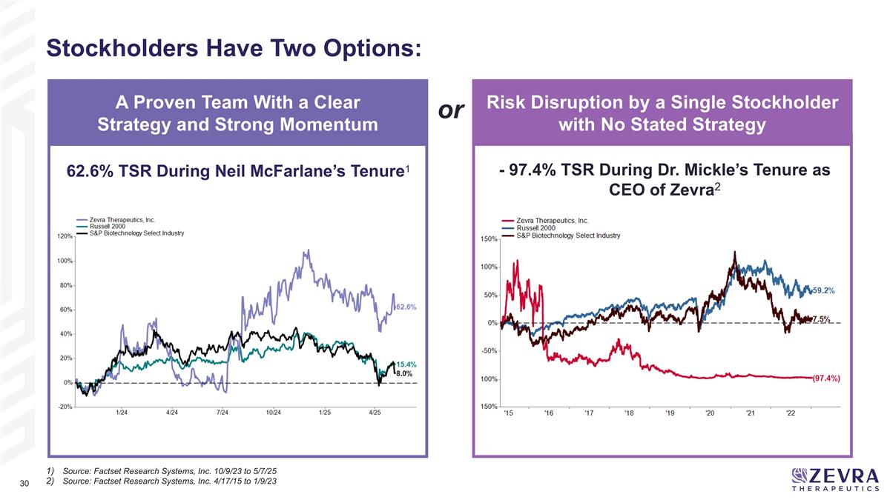
Stockholders Have Two Options: - 97.4% TSR During Dr. Mickle’s Tenure as CEO of Zevra2 62.6% TSR During Neil McFarlane’s Tenure1 Risk Disruption by a Single Stockholder with No Stated Strategy or A Proven Team With a Clear Strategy and Strong Momentum Source: Factset Research Systems, Inc. 10/9/23 to 5/7/25 Source: Factset Research Systems, Inc. 4/17/15 to 1/9/23

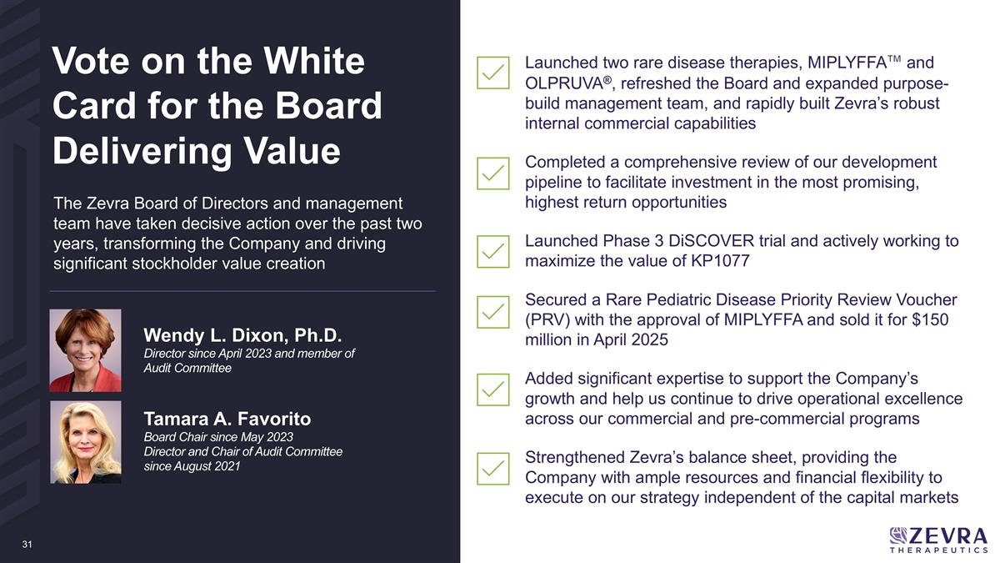
Launched two rare disease therapies, MIPLYFFA™ and OLPRUVA®, refreshed the Board and expanded purpose-build management team, and rapidly built Zevra’s robust internal commercial capabilities Completed a comprehensive review of our development pipeline to facilitate investment in the most promising, highest return opportunities Launched Phase 3 DiSCOVER trial and actively working to maximize the value of KP1077 Secured a Rare Pediatric Disease Priority Review Voucher (PRV) with the approval of MIPLYFFA and sold it for $150 million in April 2025 Added significant expertise to support the Company’s growth and help us continue to drive operational excellence across our commercial and pre-commercial programs Strengthened Zevra’s balance sheet, providing the Company with ample resources and financial flexibility to execute on our strategy independent of the capital markets Wendy L. Dixon, Ph.D. Director since April 2023 and member of Audit Committee Tamara A. Favorito Board Chair since May 2023 Director and Chair of Audit Committee since August 2021 Vote on the White Card for the Board Delivering Value The Zevra Board of Directors and management team have taken decisive action over the past two years, transforming the Company and driving significant stockholder value creation

Additional Information and Where to Find It
Zevra has filed with the SEC a definitive proxy statement on Schedule 14A, containing a form of WHITE proxy card, with respect to its solicitation of proxies for the 2025 Annual Meeting of Stockholders.
INVESTORS AND SECURITY HOLDERS ARE URGED TO READ CAREFULLY AND IN THEIR ENTIRETY THE PROXY STATEMENT (INCLUDING ANY AMENDMENTS OR SUPPLEMENTS THERETO) FILED BY ZEVRA, AND ANY OTHER RELEVANT DOCUMENTS TO BE FILED BY ZEVRA WITH THE SEC WHEN THEY BECOME AVAILABLE, BECAUSE THEY WILL CONTAIN IMPORTANT INFORMATION ABOUT ANY SOLICITATION.
Investors and security holders may obtain copies of these documents and other documents filed with the SEC by Zevra free of charge through the website maintained by the SEC at www.sec.gov. Copies of the documents filed by Zevra are also available free of charge by accessing Zevras investor relations website at investors.zevra.com.
Participants in the Solicitation
Zevra, its directors, executive officers, and employees may be deemed to be participants in the solicitation of proxies with respect to a solicitation by Zevra. Information about Zevras executive officers and directors is available under the heading Information about our Executive Officers and Directors in Part I of Zevras Annual Report on Form 10-K for the year ended December 31, 2024, which was filed with the SEC on March 12, 2025 and under the headings Proposal 1: Election of Directors, Executive Officers, Security Ownership of Certain Beneficial Owners and Management and Executive Compensation, and Director Compensation in Zevras definitive proxy statement on Schedule 14A for its annual meeting of stockholders to be held in 2025, which was filed with the SEC on April 21, 2025. To the extent holdings of our directors and executive officers of Zevra securities reported in such definitive proxy statement change, such changes will be reflected on Statements of Change in Ownership on Forms 3, 4 or 5 filed with the SEC. These documents are available free of charge at the SECs website at www.sec.gov. Copies of the documents are also available free of charge by accessing Zevras investor relations website at investors.zevra.com.

